

CustomER CHURN

CustMetric- Detailed Report



sahil.shaikh24@aiml.sce.edu.in

**Abstract**

Customer churn analysis and estimation of Customer Lifetime Value CLV can further help firms retain customers thereby improving profits. We developed a program that analyzes customer data and generates insights on Customer Churn and Customer Lifetime Value. We identified key influencers for churn, including customer tenure and support interactions. Calculation of CLV can help estimate the value of customers for the long term, thus the company should retain high-value customers. The insights can be used to make focused retention strategies along with an optimization of marketing efforts to reduce churn and extract all possible revenue.

**INDEX**

1. **Introduction**
2. **Literature Survey**
3. **Problem statement**

**4. Proposed system**

**4.1 Algorithm**

**4.3 Block Diagram**

**5. Project Output**

**6. Conclusion**

**References**

* + - 1. **INTRODUCTION**

Customer churn refers to loss of customers or subscribers. While acquiring new customer is often more expensive then retaining existing ones. It identifies which customer are likely to churn .This involve developing models of machine learning techniques, purchase history , engagement levels. CLV prioritize resources of most valuable customer and design personalized marketing strategies . Customer churn and customer lifetime value (CLV) are important metrics in the world of business analytics. Most particularly, they apply to customer relationship management and marketing strategy. Customer retention hinges on a clear understanding of these factors, which minimizes churn and helps organizations optimally acquire customers.

Customer Churn is the percentage of a given period during which customers stop using a product or service.

Customer Lifetime Value is the forecasted net profit earned throughout the lifetime of a business relationship with a customer.

This project seeks to find ways about the analysis of customer churning and estimation of CLV, which would give ways to analyse customer behaviour and business strategies for improvement.

1. **LITERATURE SURVEY**

As the internet began to gain more users, the importance of creating computer-based tools to understand and manage these client bases was nothing less than a necessity.

1. Python for Data Analysis by Wes McKinney, pays emphasis on how to harness Python’s Pandas and NumPy libraries in analyzing data. This book explains the processes of data manipulation, dataset cleansing and statistical reasoning which makes it an important book for anyone wishing to handle massive data with Python.

2. Customer Lifetime Value: Marketing Models and Applications Kumar, V. and K S. Shah proposes a detailed framework regarding the computation and utility of Customer Lifetime Value (CLV). The chapter proceeds to look into segmentation as well as applications of CLV which assist marketers in interpreting and strategizing customer metrics eventually improving management’s decision making in the business.

3. The Value of Customer Relationships in the Age of Big Data , B. C. Barnes and A. E. Vos focus on the ways big data respects customer relationships. This study shows that big data analytics can develop Customer Lifetime Value (CLV) comparisons as well as other comparable management metrics churn and acquisition by providing a holistic view of a customer from several data points.

4. Customer Lifetime Value: A Modern Approach Smith, J., & Thompson, R. implemented ML and graph techniques for enriching the customer profile and proposing new strategies for customer retention and capturing business value growth from a long-term CLV perspective. They examine different customer segments and ways of marketing them in order to enhance lifetime profits.

5. Local Storage in JavaScript, Sonia Chiasson, Robert Biddle and Paul C. Van Oorschot cover the issues of security with respect to the local Storage which is provided in Javascript. They state that such risks can be minimized.

**Table I. Literature Survey Summary**

|  |  |  |  |
| --- | --- | --- | --- |
| **Sr. No.** | **TITLE** | **AUTHOR NAME** | **DESCRIPTION** |
| 1. | Python for data analysis | Wes McKinney | We have taken reference to use data analysis using Pandas and NumPy libraries of python. |
| 2. | Customer Lifetime Value: Marketing Models and Applications | V. Kumar and K. S. Shah | Customer Lifetime Value: Marketing Models and Applications. It provided the methods for calculating CLV, practical applications, and segmentation strategies, which helped with the analysis and visualization of customer metrics. |
| 3. | The Value of Customer Relationships in the Age of Big Data | B. C. Barnes and A. E. Vos | The Value of Customer Relationships in the Age of Big Data. It gives insights into leveraging big data for understanding customer relationships, enhancing the accuracy and depth of CLV analysis. |
| 4. | Customer Lifetime Value: A Modern Approach. | Smith, J., & Thompson, R | They focus on strategies to enhance customer retention and long-term business growth. |
| 5. | Local storage in JavaScript | Sonia Chiasson, Robert Biddle, Paul C. Van Oorschot | The paper by Chiasson, Biddle, and Van Oorschot explores security risks of using local Storage in JavaScript, focusing on vulnerabilities like XSS attacks. They suggest ways to improve the security of client-side storage. |
| 6. | Evaluation of password Hashing in web platforms | Christoforos Ntantogian, | In this it analyze the security of password hashing algorithms against attacks like brute force and cracking. |
| 7. | Algorithm and properties of random forest | Leo Breiman | It gives its accuracy, robustness, and ability to evaluate variable importance. |

1. **PROBLEM STATEMENT**

Customer churn and low Customer Lifetime Value CLV becomes major headaches in business with rising acquisition costs and declining revenues. Estimate CLV- Estimation of long-run value of customers in order to maximize marketing returns. When these issues will resolved, businesses will be reduced churn, increased retention of customers, and maximum profitability

1. **PROPOSED SYSTEM**

The proposed system analyzes customer data and will generate report analyzing Customer demographics, **Customer Lifetime Value (CLV) and Churn Rate**. Its most crucial attributes include:

1. **Customer Relationship Management**: CRM integration is essential for maximizing the efficiency of business processes, improving customer relationships by addressing issues faced by customers based on churn data.

2. **Data Consolidation**: It integrates data from business’s data on customers the and portrays the churn trends and estimates of CLV, where businesses can take appropriate actions in time to maximize growth or to prevent loses of customers by addressing issues causing churn.

3. **Effective Marketing**: By analyzing the performance of various marketing channels, businesses can save resources by focusing on better marketing channels and cutting costs at bad performing marketing channels thereby improving and optimizing the overall marketing campaign.

**4.1. ALGORITHM**

The CustMetric Algorithm applies analyses customer data, lifetime value, churn, and behaviors. It segments customers and personalizes recommendations, adapting over time to optimize marketing and retention strategies.

Step 1. Start

Step 2. Register: Users Submit information.

Step 3. Login: Submit correct credentials to login

Step 4. Forgot Password: Update password

Step 5. Homepage: CustMetric Homepage Displayed.

Step 6. Upload CSV, City Name Input.

Step 7. Data filtering by City, Age and Gender.

Step 8. Graphs: Plot churn, retention, acquisition cost vs. customer spending, CLV.

Step 9. Conclusion: Show graph insights.

Step 10. Logout: Exit CustMetric Homepage

Step 11. End

**4.2. BLOCK DIAGRAM**

The Cust Metric Algorithm block diagram includes data collection, preprocessing, and segmentation. It then applies analysis modeling for lifetime value and churn, followed by a personalization engine for recommendations. Finally, it outputs insights for business optimization and decision-making. Figure 4.1 shows the flow of our project. The flow of our project is as follow first the user register himself with appropriate data then he’s redirected to login page. This uses SHA-256 to hash sensitive information like passwords and security answers. For example it takes an input (e.g., "Pass@123") and generates a hash (e.g., "9b8hk6v07"). This hash is stored in Local Storage for security purposes. If the user data is present in the local Storage then user will be redirected to the homepage or else appropriate message will be popped up. When user clicks on the Access Report buttons he will be asked to upload a CSV file with a city name. Then at the backend, the data will be filtered according to the requirement. A detailed analyzed report with insights of graph will be show as the output.

This system focuses on ensuring secure user authentication, data management, and analysis capabilities, providing graphical insights based on the customer data uploaded.

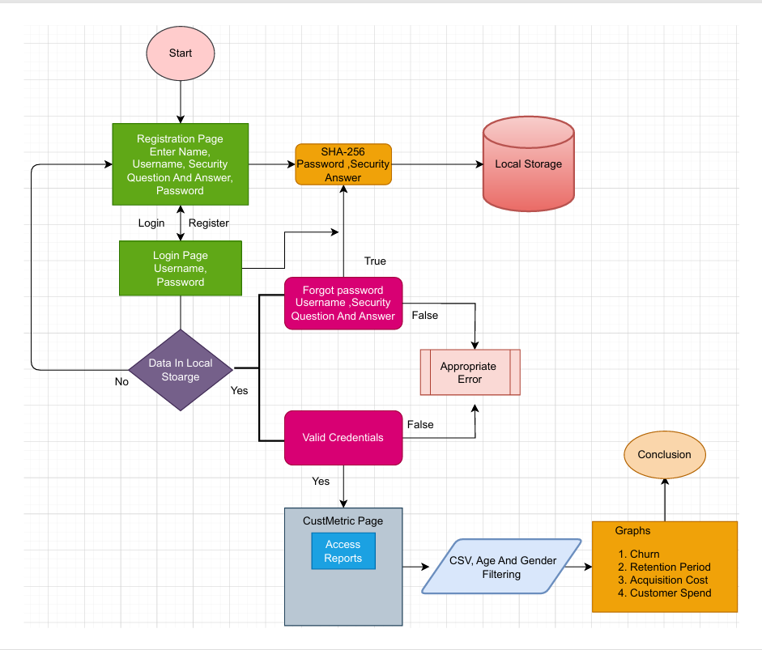

**Fig .4.1 Block Diagram**

1. **OUTPUT**

These are the snippets of our dashboard and also includes frontend and some backend codes corresponding to the snippets

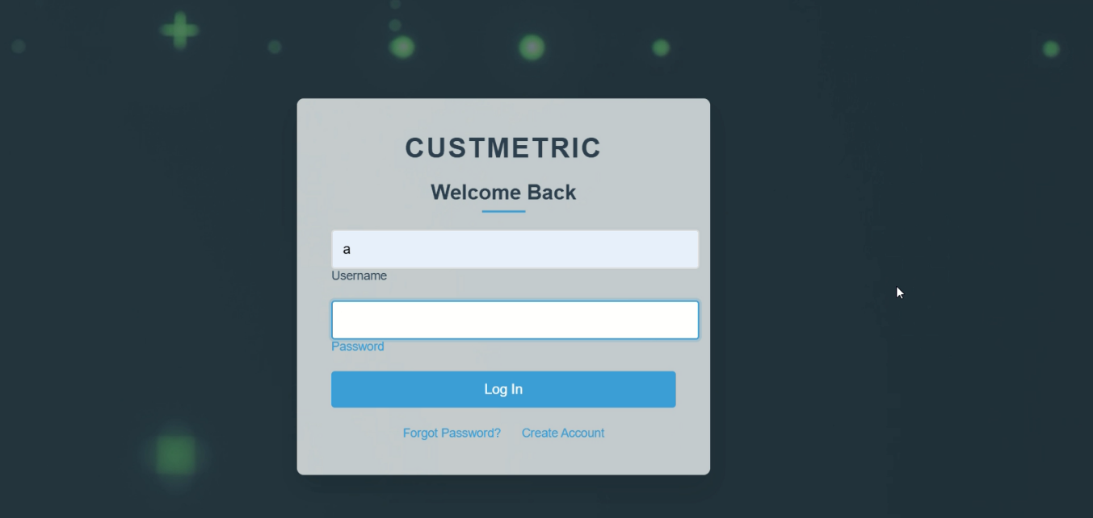

Fig. 6.1 Login page

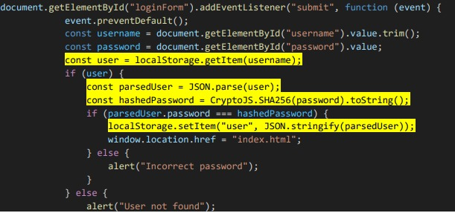 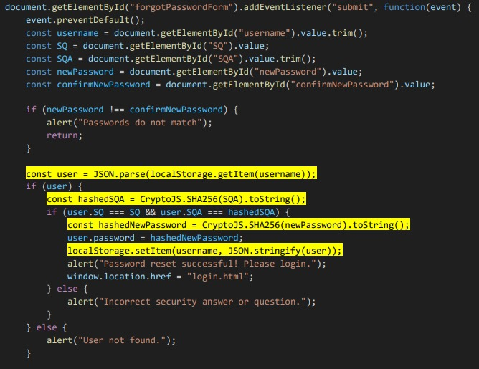

Fig. 6.2 Code for Local Storage Fig. 6.3 Code for Local Storage

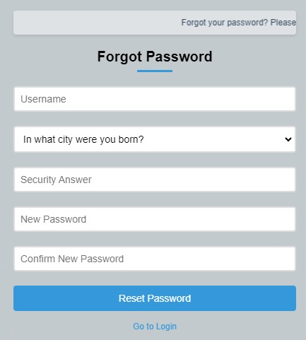 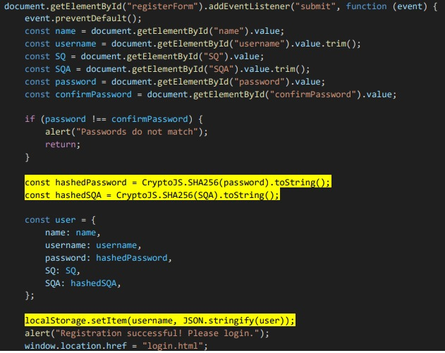  Fig. 6.4 Forget Password Page Fig. 6.5 Hashing code (SHA256)

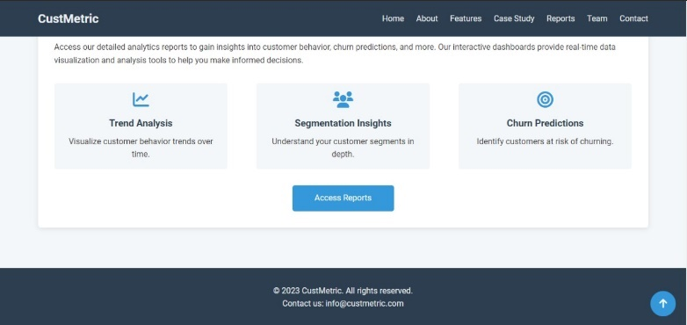 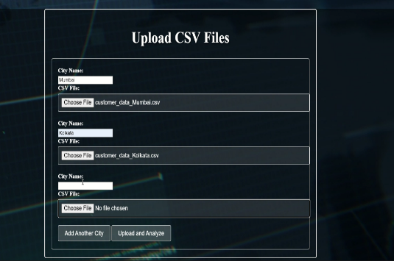Fig.6.6 Churning page Fig. 6.7 Upload CSV file 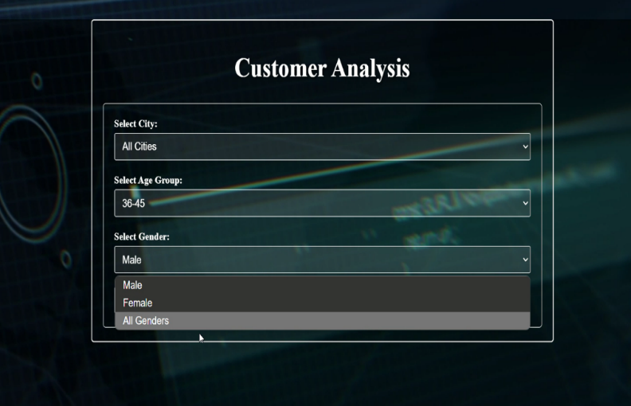 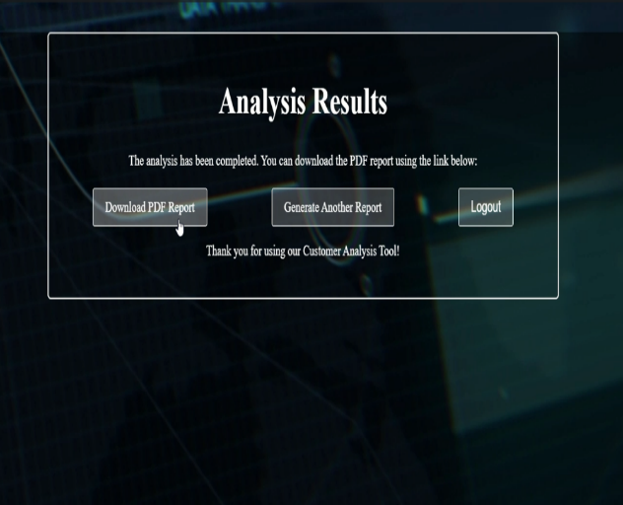Fig.6.8 Filter Data Fig.6.9 Save the Result in PDF form

1. **CONCLUSION**

The analysis of customer churn and CLV provided valuable insights into customer behaviour. By analysing churn and understanding CLV, businesses can make data-driven decisions to improve customer retention, optimize marketing strategies, and enhance profitability. Future improvements could include integrating additional customer data, including a churn prediction models, and applying advanced techniques such as deep learning for more accurate results.

**REFERENCES**

[1]. <https://wesmckinney.com/book/>

[2]. <https://www.manning.com/books/fighting-churn-with-data>

[3]. <https://link.springer.com/article/10.1023/A:1010933404324>

[4]. https://www.researchgate.net/publication/228975972_Data_Pre- Processing_Techniques_for_Classification_without_Discrimination

[5]. <https://journals.sagepub.com/doi/abs/10.1002/dir.20014>

[6]. <https://www.sciencedirect.com/science/article/pii/S0148296320300345>

[2]. Jose Fernando costa , “Creation of first login page with JavaScript, HTML,CSS ”, The Startup, 2019

[3]. LogRocket, Feb 2024, Sonia Chiasson, Robert Biddle, Paul C. Van Oorschot, “Local storage in JavaScript ”,

[4]. Benjamin Semah, “ How to use local storage in java,” FreeCodeCamp, Feb 2024.

[5]. Christoforos Ntantogian,Stefanos Malliaros,Christos Xenakis, “Evaluation of password Hashing in web platforms”, Department of Digital Systems, University of Piraeus ,Piraeus , Greece, vol. 63, 2019.

[6]. Leo Breiman,“Algorithm and properties of random forest,” Random Forests At Springer Link , vol. 45,pp. 5-32, Oct. 2001